 | Project Design Phase-II
 | Data Flow Diagram &User Stories
Date |  | 03 November 2022
Team ID |  | PNT2022TMID31851
Project Name |  | Project - Visualising and predicting heart
 |  | disease with an interactive dashboard
Maximum Marks |  | 4 Marks

Data Flow Diagrams:

A Data Flow Diagram (DFD) is a traditional visual representation of the information flows within a system. A neat and clear DFD can depict the right amount of the system requirement graphically. It shows how data enters and leaves the system, what changes the information, and where data is stored.
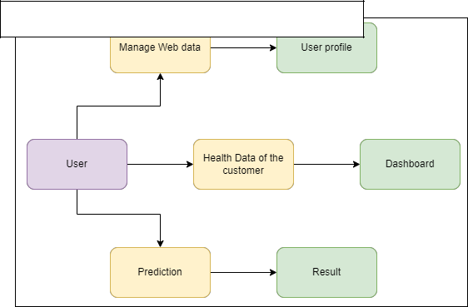

Example: Visualising and predicting heart disease with an interactive dashboard

Example: DFD Level 0 (Industry Standard)

User Stories

Use the below template to list all the user stories for the product.

User Type | Functional | User Story | User Story / Task | Acceptance criteria | Priority | Release
 | Requirement | Number
 | (Epic)
Customer | Registration | USN-1 | As a user, I can register for the application by | I can access my account / | High | Sprint-1
(Mobile user) |  |  | entering my email, password, and confirming | dashboard
 |  |  | my password.
 |  | USN-2 | As a user, I will receive confirmation email | I can receive confirmation | High | Sprint-1
 |  |  | once I have registered for the application. | email & click confirm
 |  | USN-3 | As a user, I can register for the application | I can register & access the | Low | Sprint-2
 |  |  | through Facebook. | dashboard with Facebook
 |  |  |  | Login
 |  | USN-4 | As a user, I can register for the application |  | Medium | Sprint-1
 |  |  | through Gmail.
Customer (Web | Login | USN-5 | As a user, I can log into the application by |  | High | Sprint-1
user) |  |  | entering email & password
 | Dashboard | USN-6 | User can able to view only his medical | I can view it in Dashboard | High | Sprint-2
 |  |  | records.
 |  | USN-7 | User can able to view the possibilities of | I can view it in the analysis | High | Sprint-2
 |  |  | occurrence of heart disease. | reports.
Customer Care | Helpdesk | USN-8 | Able to view the queries | I can able to post queries | Medium | Sprint-3
Executive |  |  |  | on dashboard
 |  | USN-9 | Able to answer queries | I can able to view the | High | Sprint-3
 |  |  |  | answers for those queries
Administrator | User Profile | USN-10 | Able to update the users medical records | I can view my updated | High | Sprint-4
 |  |  |  | health details.
 |  | USN-11 | Able to add or delete users | I can access my accounts | High | Sprint-4
 |  |  |  | when logged in.
 |  | USN-12 | Able to manage the user details | I can view the organized | High | Sprint-4
 |  |  |  | data of myself.

